**Coordinate Geometry**

1. Two perpendicular number lines intersecting at point zero are called **coordinate axes**. The horizontal number line is the ***x*-axis** (denoted by *X’OX*) and the vertical one is the ***y*-axis** (denoted by *Y’OY*). The point of intersection of *x-*axis and *y-*axis is called **origin** and denoted by ‘*O*’.
2. **Cartesian plane** is a plane obtained by putting the coordinate axes perpendicular to each other in the plane. It is also called coordinate plane or *xy* plane.
3. The **x-coordinate** of a point is its perpendicular distance from *y-*axis.
4. The **y-coordinate** of a point is its perpendicular distance from *x-*axis.
5. The point where the *x* axis and the *y* axis intersect is represented by coordinate points (0, 0) and is called the **origin**.
6. The **abscissa** of a point is the *x*-coordinate of the point. The **ordinate** of a point is the *y-*coordinate of the point.
7. If the abscissa of a point is *x* and the ordinate of the point is *y*, then (*x, y*) are called the **coordinates**

of the point.

1. The axes divide the Cartesian plane into four parts called the **quadrants** (one fourth part), numbered I, II, III and IV anticlockwise from *OX*.
2. Sign of coordinates depicts the quadrant in which it lies. The coordinates of a point are of the form

(+, +) in the first quadrant, (-, +) in the second quadrant, (-,-) in the third quadrant and (+,-) in the fourth quadrant.

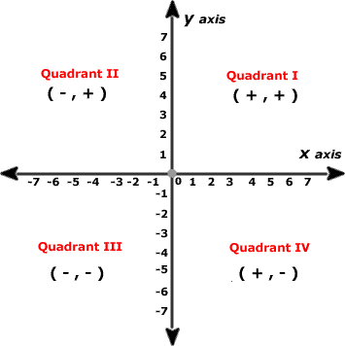

1. The coordinates of a point on the *x*-axis are of the form (*x*, 0) and that of the point on *y*-axis are (0, *y*).
2. To plot a point P (3, 4) in the Cartesian plane, start from origin and count 3 units on the positive *x* axis then move 4 units towards positive *y* axis. The point at which we will arrive will be the point *P* (3, 4).

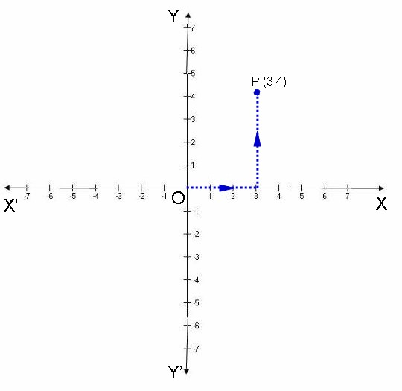

1. If *x ≠ y*, then (*x, y)* ≠ *(y, x)* and if *(x, y) = (y, x)*, then *x* = *y*.